**Q1. Find IP information assigned to your computer (IP address, DNS IP address, Gateway IP address)**

Windows: ipconfig

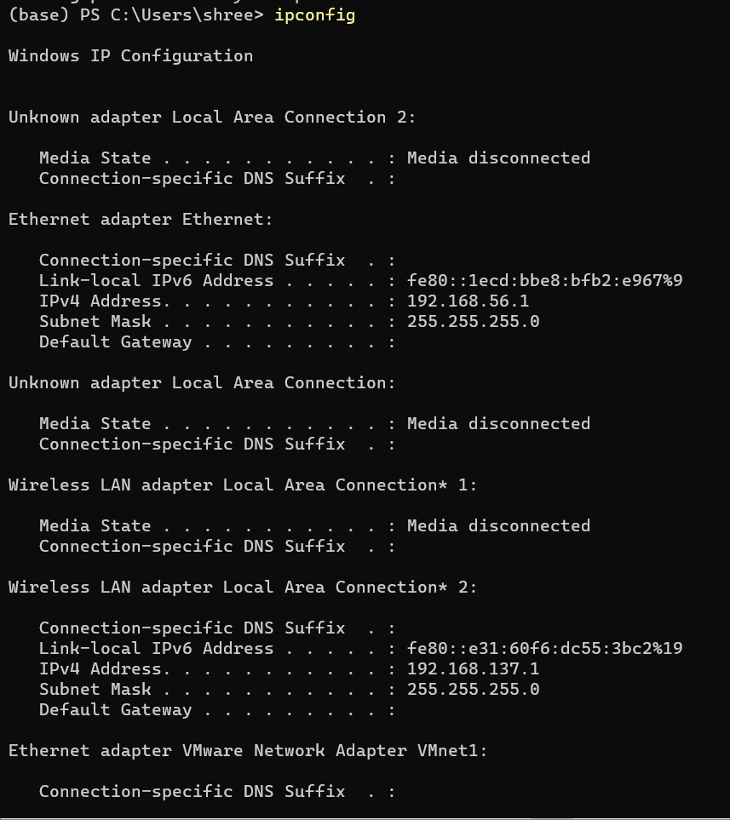

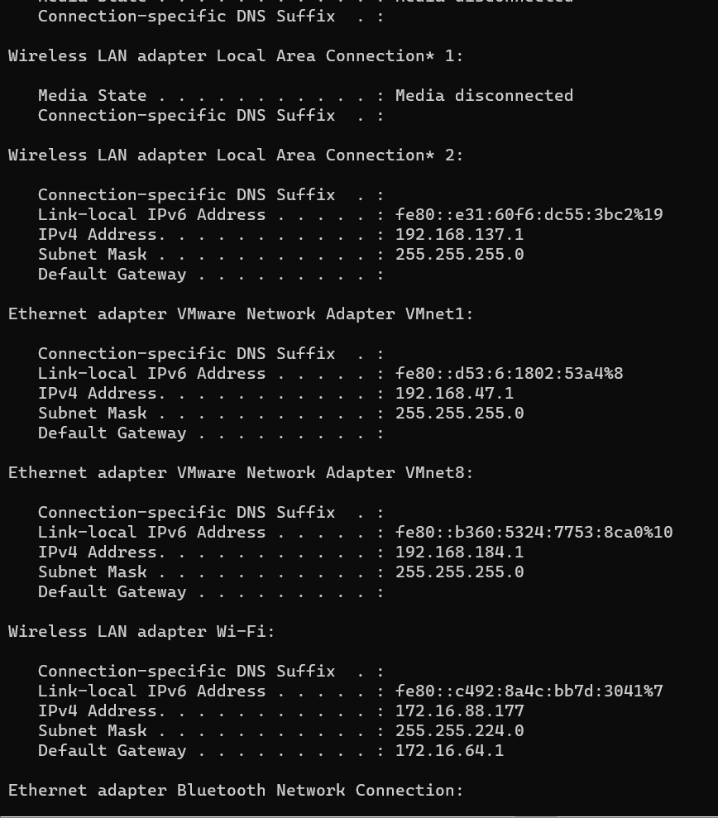

LINUX: ifconfig

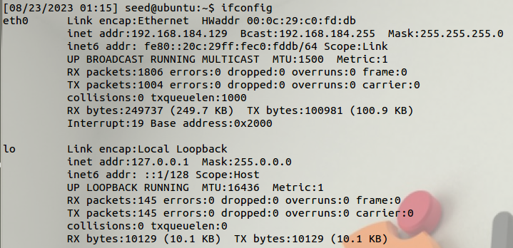

**Q2. Check different interfaces connected to the network.**

**WINDOWS:**



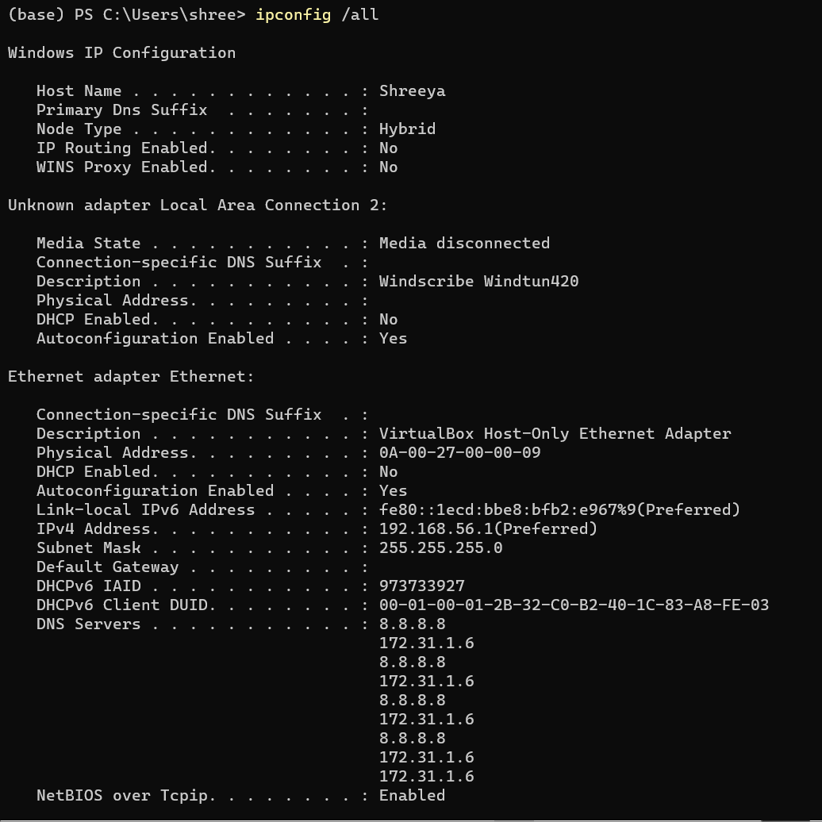

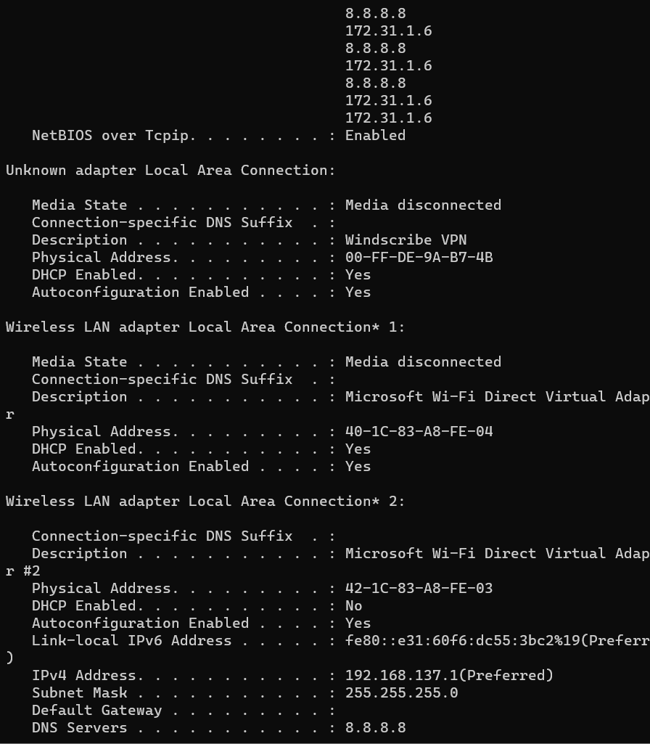

**LINUX:**



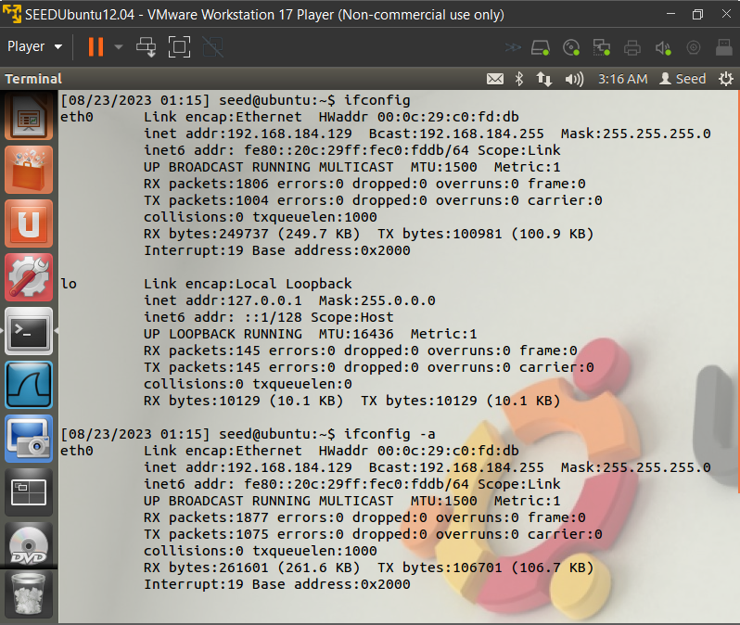

**Q3. Alter the status of any interface**

**• Set it to Offline mode**

**• Set it again to Online mode**

**Before down:**

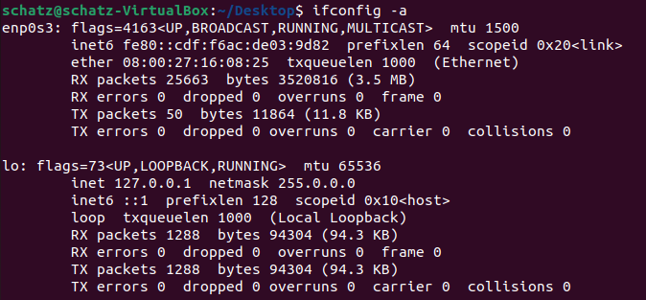

After running: **sudo ifconfig enp0s3 down**

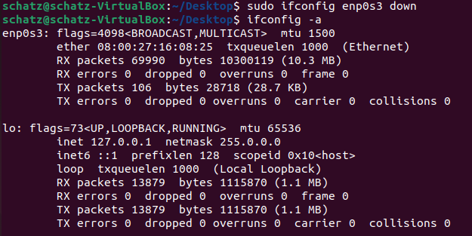

RECONNECTING: **sudo ifconfig enp0s3 up**

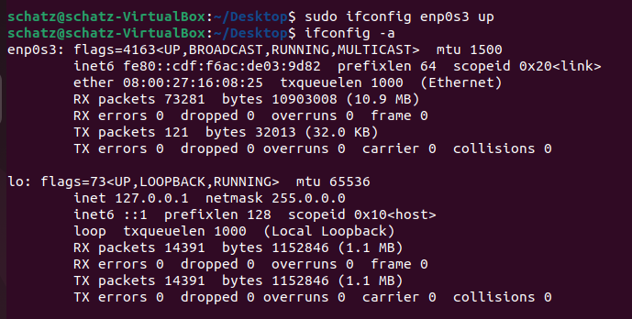

**Q4. Change the MTU size of a packet**

Checking the current MTU sizes: **ip a | grep mtu**

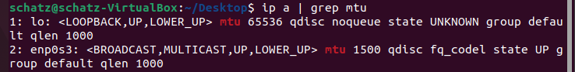

After running:  **ifconfig enp0s3 mtu 1000 up**

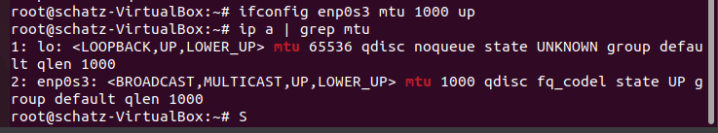

**The MTU of enp0s3 changes from 1500 to 1000.**

Now reset it to default:

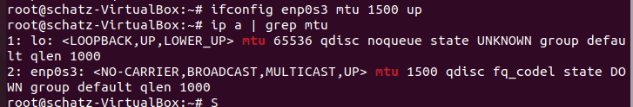

**Q5. Find the subnet mask**

The subnet mask can be found out as: ifconfig | grep -i mask



**Q6. Calculate number of host ids in your subnet**

Subnet mask: 255.0.0.0

Binary Representation: 11111111.00000000.00000000.00000000

Number of zeroes in the binary representation: 24

Number of unique host addresses: 2^24

Actual number of hosts within this subnet= **2^24-2** (we subtract 2 to account for the network and broadcast addresses which are reserved)

Value= **16,777,214-** usable host ids

**Q7. Find the network and broadcast address of the network you are connected to.**

Subnet mask: 255.0.0.0

Binary Representation: 11111111.00000000.00000000.00000000

Flipped Binary Representation: 00000000.11111111.11111111.11111111

Flipped decimal: **0.255.255.255**

Thus **0.255.255.255** is the Broadcast address.

**Q8.**

**a) Ping the DNS server and check the response.**

SERVER INFORMATION:

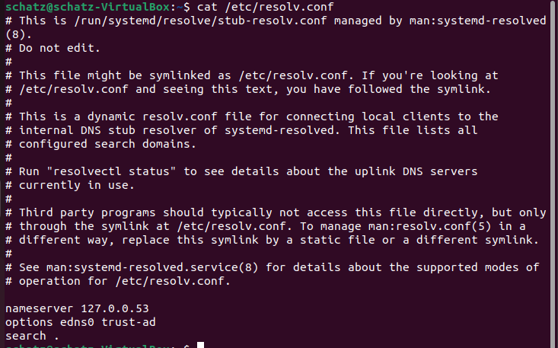

Thus the DNS Server IP Address is 127.0.0.53

**After Ping:**

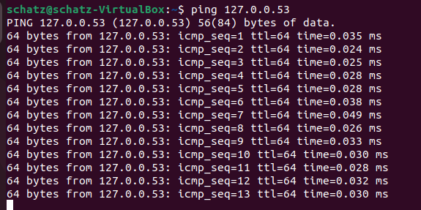

**b) Ping 8 echo requests with each packet of size 50 to any domain name/IP address and check the response.**

**WINDOWS:**

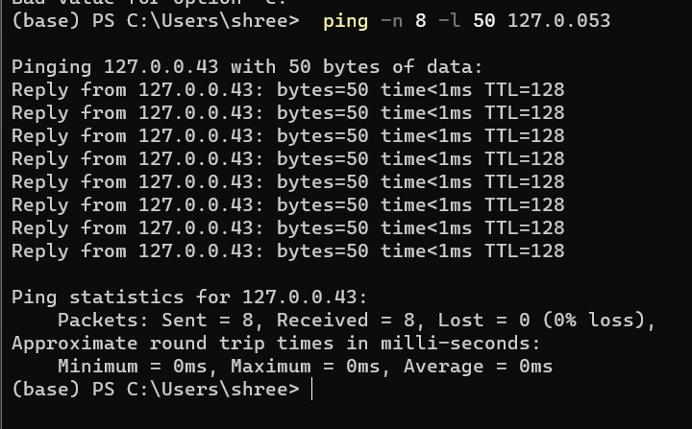

**LINUX:**

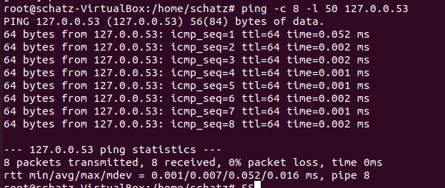

**c) Ping 8 echo requests with each packet of size 100000 to any domain name/IP address and check the response**

**WINDOWS:**

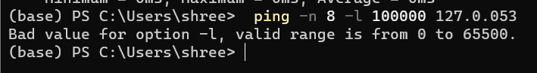

**LINUX:**



**Q9. Find the MAC address of your device. Retrieve both the Manufacturer Id (Manufacturer as well) and the device ID.**

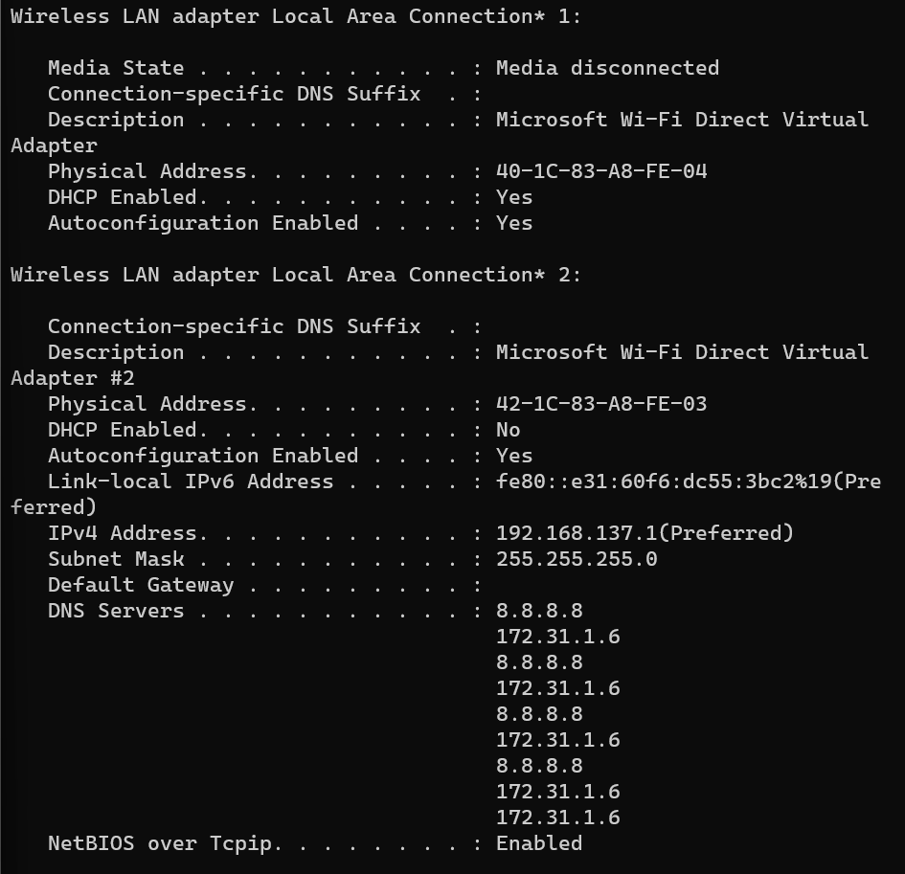

**MAC Address:** 40-1C-83-A8-FE-04

In OUI LOOKUP:

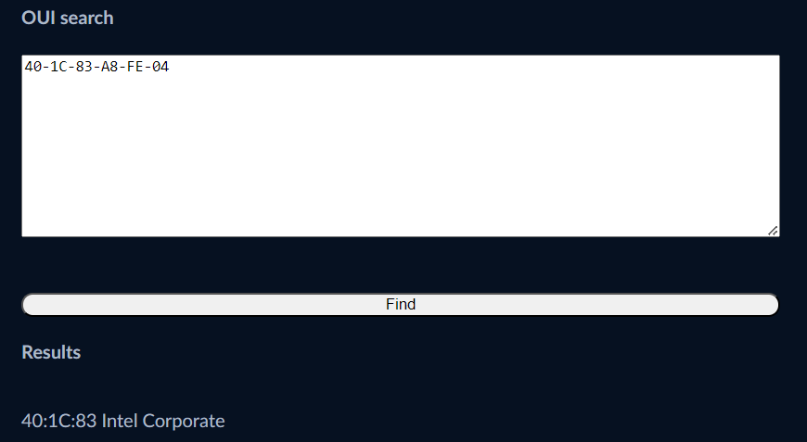

**Q10. What is the Private and Public IP address assigned for your current connection.**

PRIVATE:

For the UBUNTU VM:

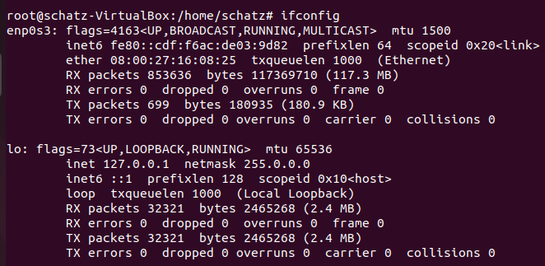

Then the private ip: 127.0.0.1

For the Host OS: WINDOWS:

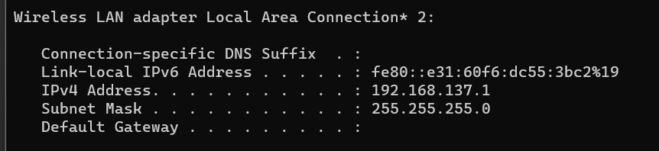

Then the private ip: 192.168.137.1

PUBLIC: 112.169.6.74

whatismyip.com

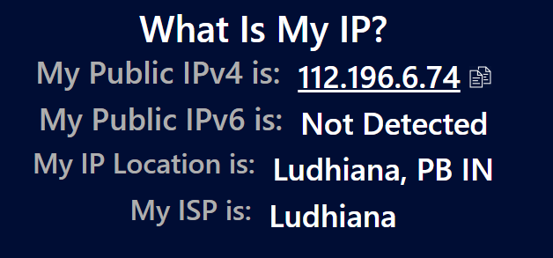

**Q11. How can you redirect the traffic through a particular gateway?**

Checking the current routes:

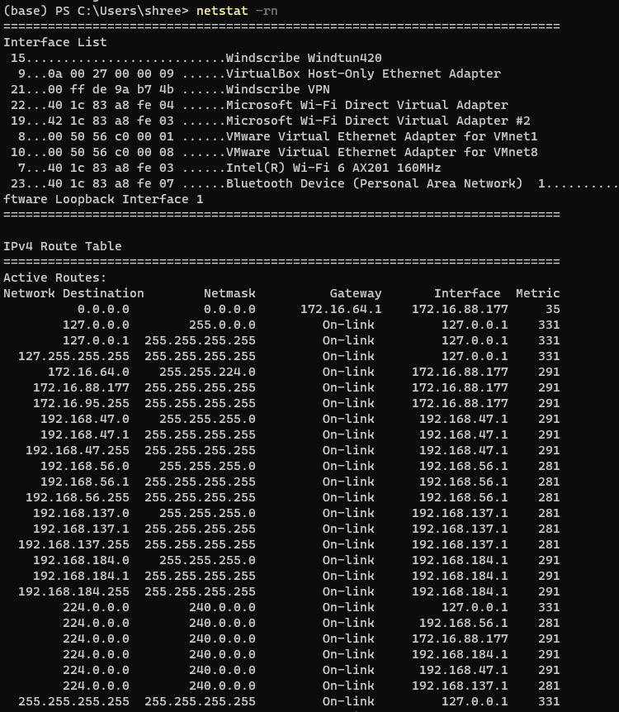

Here 1.1.1.1 does not exist

Adding a static route for example:

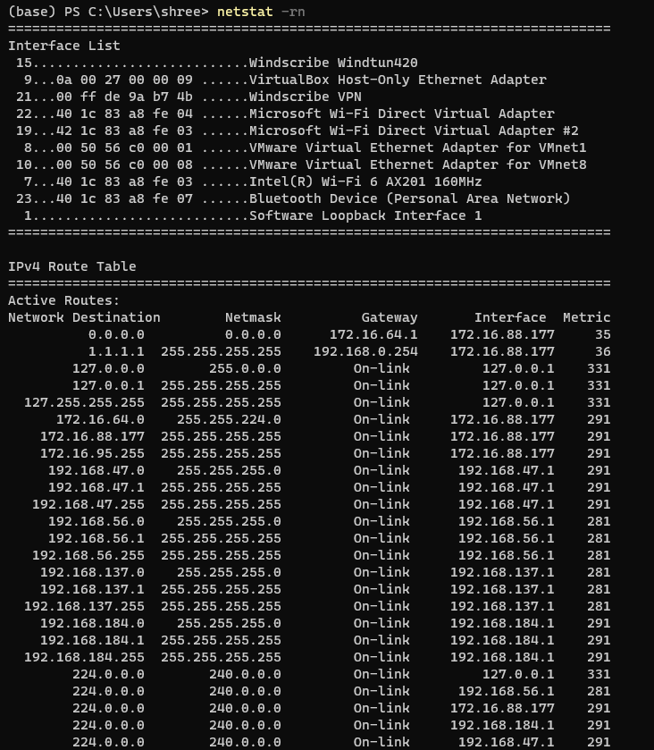

**Q12. Look for the address of the default gateway and firewall.**

From **ipconfig**

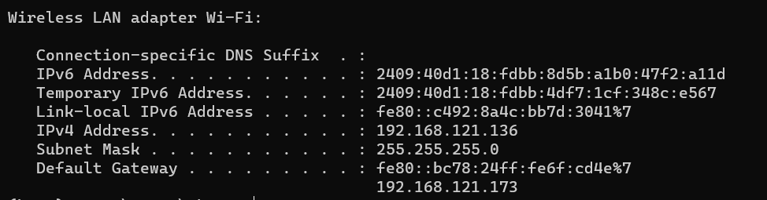

**Q13. Find the DHCP Server IP address (if enabled)**

Code: **ipconfig /all**

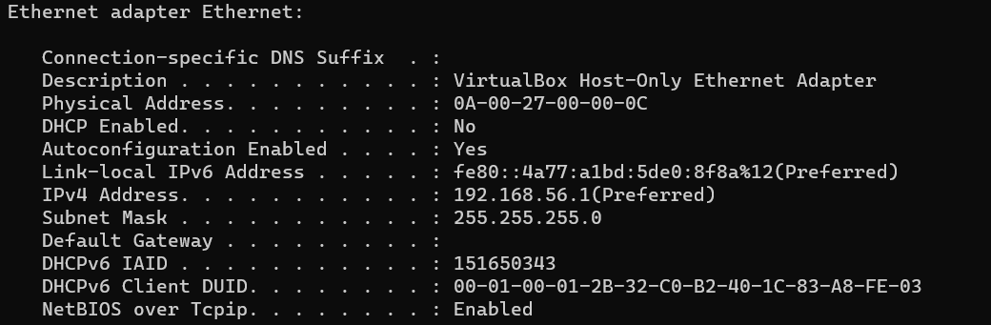

**Q14. Count number of hosts traveled by packet to reach the destination organization. What is the Ipaddress of second last host.**

Command: **tracert <ip_address>**

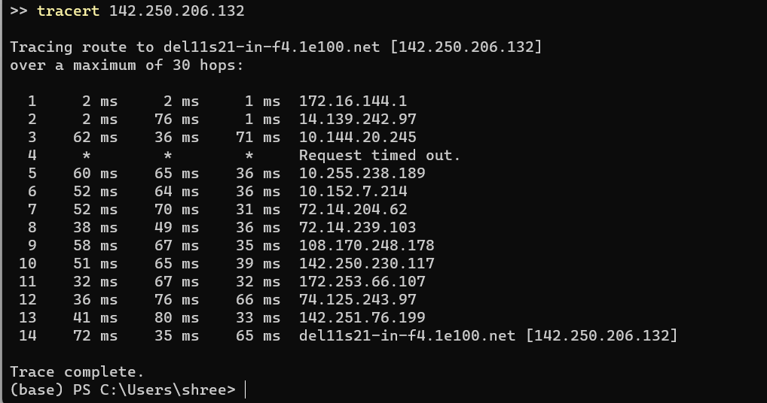

The IP address of the 2nd last host is **142.251.76.199**

**Q15. Generate a report of mtr command result (Use Ubuntu for this command) (Try to set different attributes for the same e.g. hops, number of pings etc.)**

**a**)Generating the mtr report:Command: **mtr 117.203.246.106**

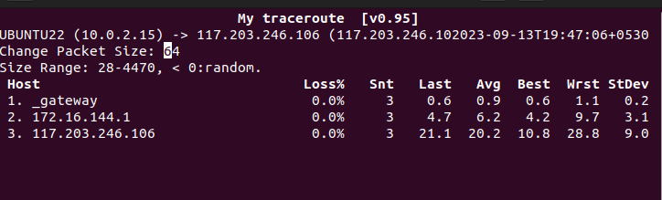

**b)**Generating the report with 10 hops and 5pings: Command: **mtr -h 10 -c 5 117.203.246.106**